# Data Structures

## Why are they important?

They affect how the computer accesses and analyses data. A function which could be used in one cannot be used in another. A lack of understanding of these would hinder the developer from being able to effectively troubleshoot when something goes wrong.

## Linked List

* Contains two property: one which stores the value, another which points to the next item on the list.
* Pros – easy to expand, unlike arrays where you have to confirm you have enough space for a new array before creating it
* Cons – take up more memory, cannot directly access a particulare node – have to move through it sequentially *Note: accessing linked list is O(n).
* The “next” property points at a new node (as a whole).
* **Doubly linked list** : on top of a “data: ” and ”next:”, doubly linked list have “previous:” which reference the previous item on the list, make traversing two-way instead of one-way. Think of a playlist of songs on a streaming service.

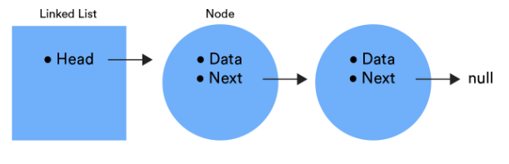

### Traversing a linked list

let walker = this.head;

while(walker.next){

walker = walker.next;

}